Epiphany (Observed)– Wednesday, January 5th, 2022 – 7:00 pm
Music Today Mark Gould
AS WE GATHER
Today we consider Jesse’s tree, that is, his family tree. His son David kept faithful to God, but succeeding generations wandered away, until only a stump remained. From that stump, a Branch would come: our Lord Jesus, who fulfills all ancient promises. Each week, we hear the story of several ancestors of Jesus - Each story showing God’s plan of salvation and how He guided humanity to prepare for His coming. The tradition of the Jesse Tree dates back to the Middle Ages, and derives its name from Isaiah 11:1, “Then a shoot will spring from the stump of Jesse, and a Branch from his roots will bear fruit.” Jesse is the father of King David, and from the family line of David, our Savior came. Today, come and see YOUR place in God's family tree!
Gathering Song Light of Light, O Sole-Begotten LSB 914
Welcome & Invocation Pastor Aaron Boerst
Call to Worship
Pastor: Jesus Christ, you are the light of the world; the light no darkness can overcome; Stay with us now, for it is evening, and the day is almost over. Let your light scatter the darkness, and shine within your people here:
Opening Song Joyous Light
^{1.}Joyous light of heav’nly glory, loving glow of God’s own face,
You who sing creation’s story, shine on ev’ry land and race.
Now as evening falls around us, we shall raise our songs to you,
God of daybreak, God of shadows, come and light our hearts anew.
^{2.} In the stars that grace this darkness, in the blazing sun of dawn,
In the light of peace and wisdom, we can hear your quiet song.
Love that fills the night with wonder, love that warms the weary soul,
Love that bursts all chains asunder, set us free and make us whole.
^{3.} You who made the heaven’s splendor, ev’ry dancing star of night,
Make us shine with gentle justice, let us each reflect your light,
Mighty God of all creation, gentle Christ who lights our way,
Loving Spirit of salvation, lead us on to endless day.
Confession and Forgiveness (Psalm 80:19; Isaiah 61:1)
Pastor: As God’s people today, we confess our brokenness and ask to be restored into a right
relationship into our Lord’s family.
People: Heavenly Father, we confess that we are bound to sin and cannot free ourselves. Like Adam in the beginning, we have “eaten forbidden fruit” in our thoughts, words, and deeds. We have not produced spiritual fruit in living the new life of faith You have won for us. We have acted as if we are not part of your family. For the sake of Jesus’ sacrifice on the tree of the cross, grant us Your mercy.
Pastor: Almighty God, our heavenly Father, has had mercy upon us and given to us His only Son to
suffer and die for our salvation. As a called and ordained servant of Christ and by His authority, I therefore forgive you all your sins in the name of the Father and of the Son and of the Holy Spirit.
People: Amen.

Prayer of the Day
Pastor: O almighty God, we come before you today, remembering your ancient words: A shoot will come up from the stump of Jesse. And from His roots a Branch will bear fruit.
Long before Jesus was born you gave life to a man named Jesse, whose son came Your promised King, David. And from David, you fulfilled your promise of a Savior, your Son Jesus Christ. Dear God, as members of your family today, we thank you that you have a plan for each of us in these last days. Help us to be patient as we wait for Jesus again.
People: Amen.
Old Testament Reading Genesis 1:1-5
(The Light in the Beginning)
1In the beginning, God created the heavens and the earth. 2The earth was without form and void, and darkness was over the face of the deep. And the Spirit of God was hovering over the face of the waters.
3And God said, “Let there be light,” and there was light. 4And God saw that the light was good. And God separated the light from the darkness. 5God called the light Day, and the darkness he called Night. And there was evening and there was morning, the first day.
Pastor: This is the Word of our Lord.
People: Thanks be to God.
Second Reading Revelation 21: 9-10, 22-24
(The New Heavens and New Earth)
9Then came one of the seven angels who had the seven bowls full of the seven last plagues and spoke to me, saying, “Come, I will show you the Bride, the wife of the Lamb.” 10And he carried me away in the Spirit to a great, high mountain, and showed me the holy city Jerusalem coming down out of heaven from God,
22And I saw no temple in the city, for its temple is the Lord God the Almighty and the Lamb. 23And the city has no need of sun or moon to shine on it, for the glory of God gives it light, and its lamp is the Lamb. 24By its light will the nations walk, and the kings of the earth will bring their glory into it.
Pastor: This is the Word of our Lord.
People: Thanks be to God.
Gospel Reading John 1:1-14
(Jesus is the Light of the World)
1In the beginning was the Word, and the Word was with God, and the Word was God. 2He was in the beginning with God. 3All things were made through him, and without him was not any thing made that was made. 4In him was life, and the life was the light of men. 5The light shines in the darkness, and the darkness has not overcome it.
6There was a man sent from God, whose name was John. 7He came as a witness, to bear witness about the light, that all might believe through him. 8He was not the light, but came to bear witness about the light.
9The true light, which enlightens everyone, was coming into the world. 10He was in the world, and the world was made through him, yet the world did not know him. 11He came to his own, and his own people did not receive him. 12But to all who did receive him, who believed in his name, he gave the right to become children of God, 13who were born, not of blood nor of the will of the flesh nor of the will of man, but of God.
14And the Word became flesh and dwelt among us, and we have seen his glory, glory as of the only Son from the Father, full of grace and truth.
Pastor: This is the Word of our Lord.
People: Thanks be to God.

Song of the Day Brightest and Best of the Stars of the Morning LSB 400 1-3
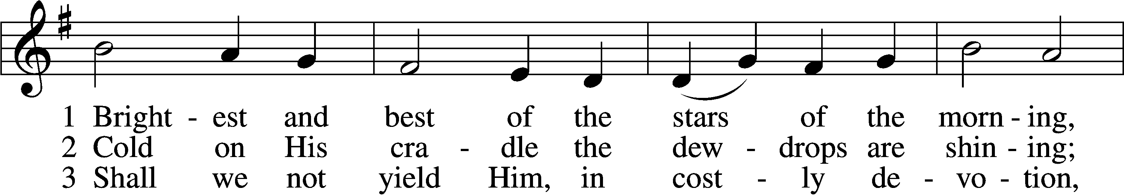
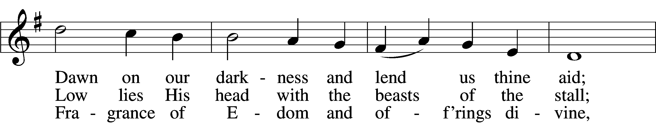
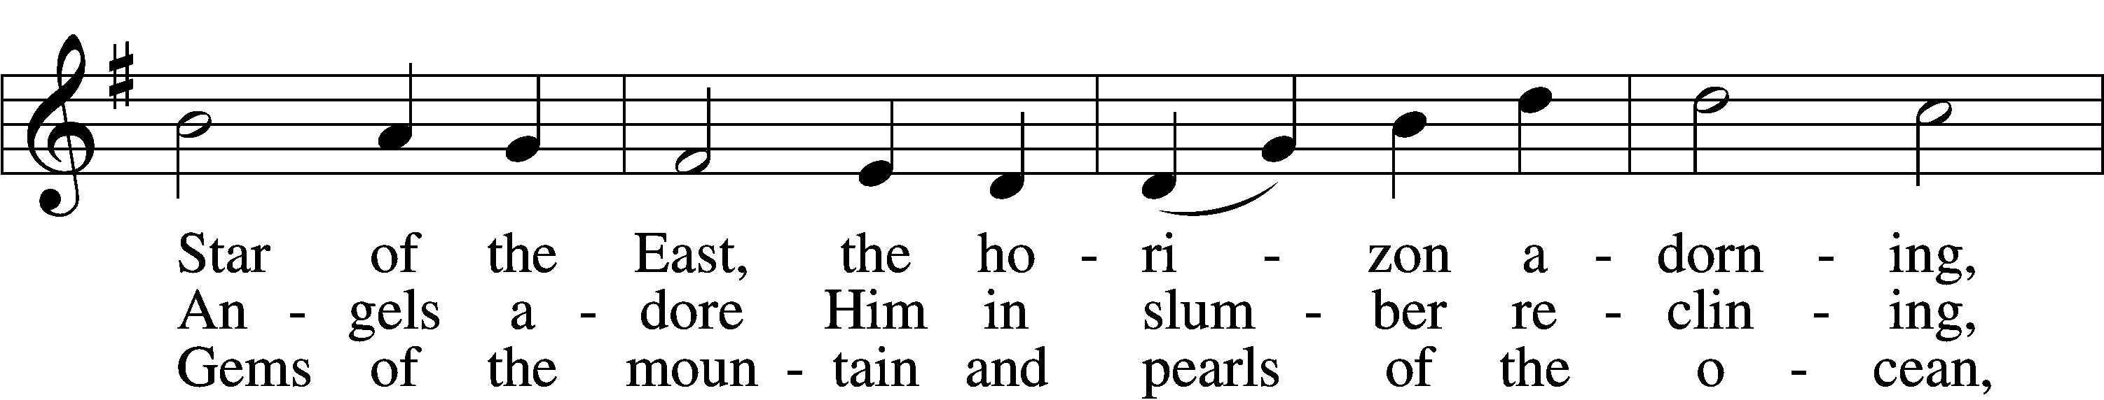
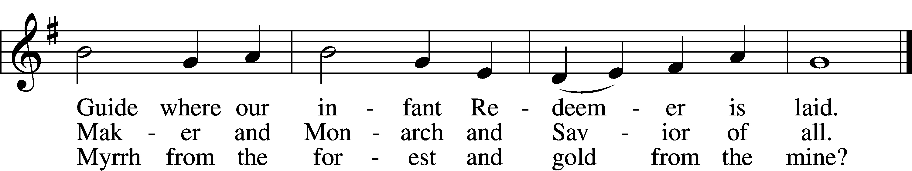
Text and tune: Public domain
Sermon The Jesse Tree: The Light of the World Pastor Aaron Boerst
Creed – APOSTLE’S CREED
I believe in God, the Father Almighty, maker of heaven and earth.
And in Jesus Christ, His only Son, our Lord, who was conceived by the Holy Spirit, born of the virgin Mary, suffered under Pontius Pilate, was crucified, died and was buried. He descended into hell. The third day He rose again from the dead. He ascended into heaven
and sits at the right hand of God the Father Almighty. From thence He will come to judge the living and the dead.
I believe in the Holy Spirit, the holy Christian Church, the communion of saints, the forgiveness of sins, the resurrection of the body, and the life everlasting. Amen.
Prayers of God’s People
Pastor: Lord God, merciful Father, we praise and thank You for Your gift of life, especially the new life You give us in the water of Holy Baptism and for teaching us to be Your new creation by Your Holy Word. Having given us this new life by Your Holy Spirit, cause us to live in Your love actively, faithfully caring for and serving our neighbor. Give us confidence in Your never-failing love and help. Lord, in Your mercy,
People: hear our prayer.
Pastor: As Your Son brought Light and Love into this world, help us to be faithful to You as You are to us, that we may demonstrate the beauty of Your love, which You give on the whole world. Bless all pastors and leaders in the Church to proclaim faithfully Your glorious salvation to all and bind us in one mission of love and service to one another and to the world. Lord, in Your mercy,
People: hear our prayer.
Pastor: O Lord, bless our nation and all who serve in the offices of government. Preserve and protect all who serve in the armed forces of our country. Grant that justice and honor prevail in society that we may dwell in peace all our days. Lord, in Your mercy,
People: hear our prayer.
Pastor: We here remember before You all who are in sorrow, need, sickness, or adversity. By Your Spirit, calm their fears, grant healing and especially steadfastness and confidence of faith in Your never-ending kindness and power to help. Be with all to whom death draws near. Grant Your compassion and skill to all who care for those who suffer. Lord, in Your mercy,
People: hear our prayer.
Pastor: With reverence and affection we remember before You, O Lord, all our friends and relatives who have departed in faith. Keep us in the true faith that we may ever hold the sure hope of eternal life in the marriage feast that has no end. Lord, in Your mercy,
People: hear our prayer.
Pastor: O Lord, Hear us on behalf of those in our congregation and all who stand in need:
Local concerns are added by congregational elder here.
Pastor: Into Your hands, O Lord, we commend ourselves and all for whom we pray, trusting in Your mercy, through Your Son, Jesus Christ, our Lord.
People: Amen.
Sharing the Peace
Offering The People That in Darkness Sat LSB 412 vv1-4
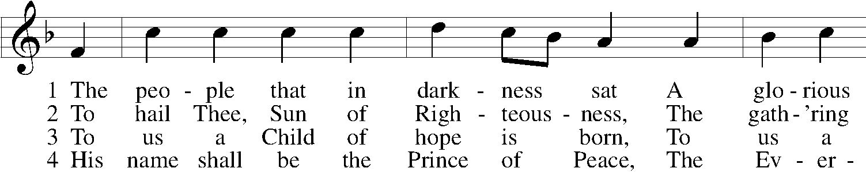
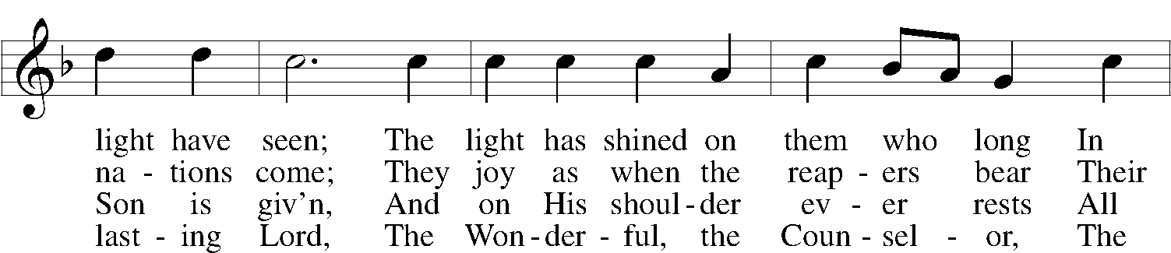
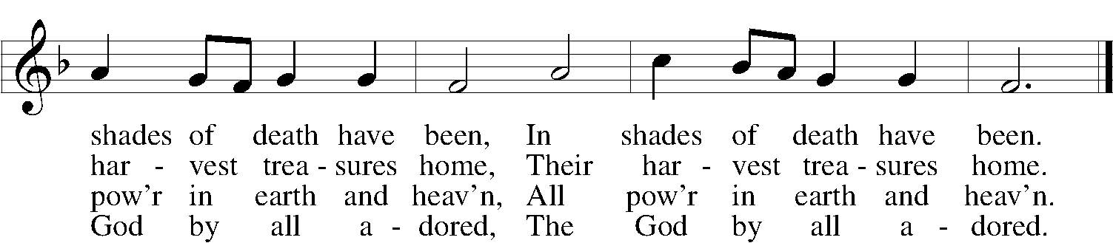
Text and tune: Public domain
Presentation of Gifts
Pastor: Heavenly Father, You are the giver of all good things, and Your Word makes clear that every
good and perfect gift comes from You. We ask that You accept these gifts back unto
Yourself and use them to Your glory. [Psalm 145:15, James 1:17]
People: Amen.
Holy Communion
Preface
Pastor: The Lord be with you. [2 Timothy 4:22]
People: And also with you.
Pastor: Lift up your hearts. [Colossians 3:1]
People: We lift them to the Lord.
Pastor: Let us give thanks to the Lord our God. [Psalm 136]
People: It is right to give Him thanks and praise.
The Words of Our Lord [Matthew 26:26–28; Mark 14:22–24; Luke 22:19–20; 1 Corinthians 11:23–25]
Proclamation of Christ
Pastor: As often as we eat this bread and drink this cup, we proclaim the Lord’s death until He comes.
[1 Cor.11:26]
People: Amen. Come, Lord Jesus. [Revelation 22:20]
Lord’s Prayer [Matthew 6:9–13]
Pastor: Lord Jesus Christ, remember us in Your kingdom and teach us to pray:
People: Our Father who art in heaven, hallowed be Thy name, Thy kingdom come, Thy will be done on earth as it is in heaven; give us this day our daily bread; and forgive us our trespasses as we forgive those who trespass against us; and lead us not into temptation, but deliver us from evil. For Thine is the kingdom and the power and the glory forever and ever. Amen.
Distribution
O God of God, O Light of Light LSB 810
I Want to Walk as a Child of the Light LSB 411
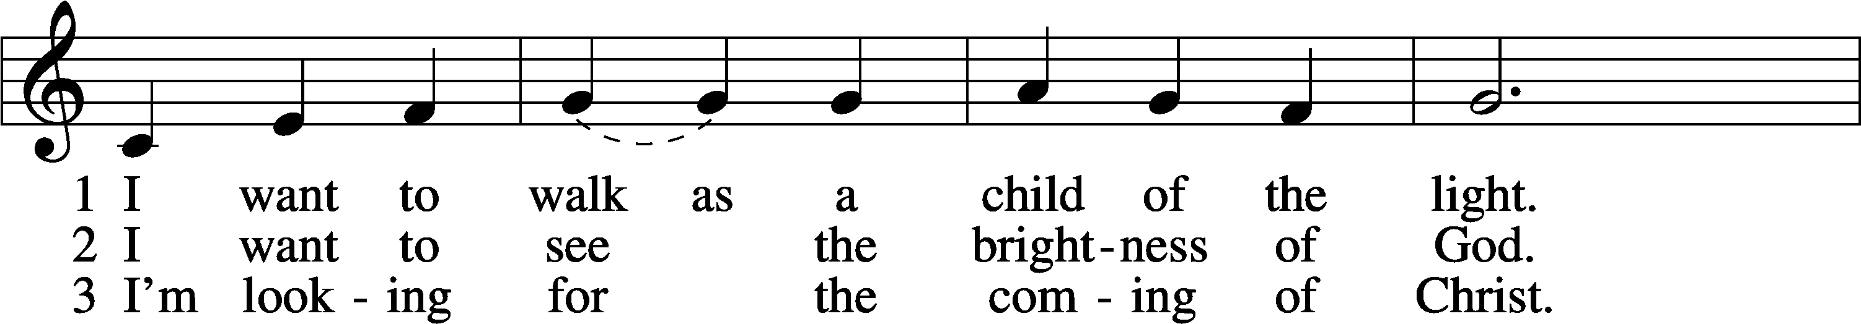
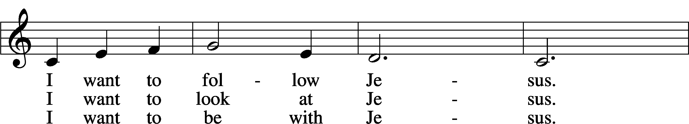
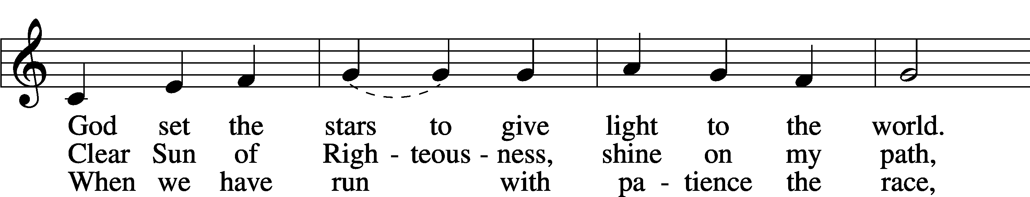
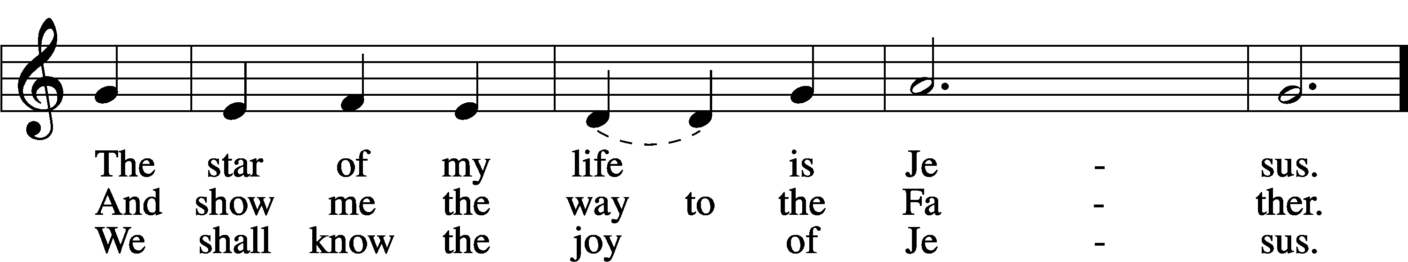
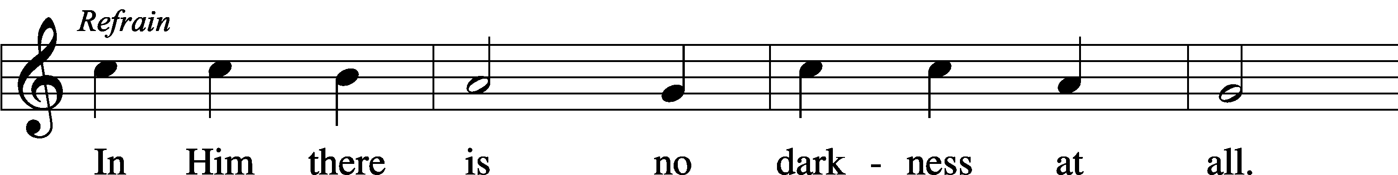
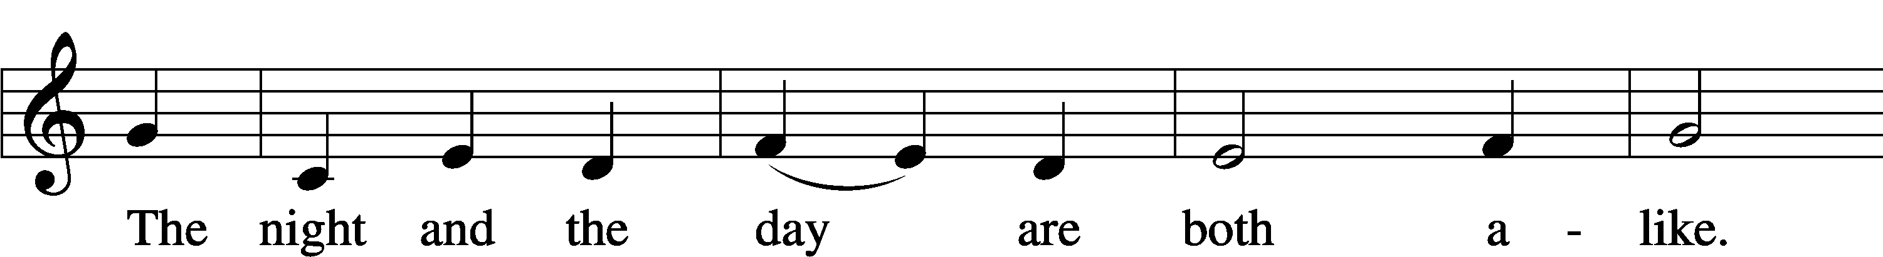
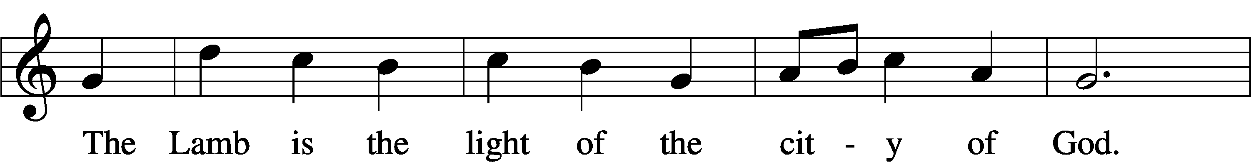
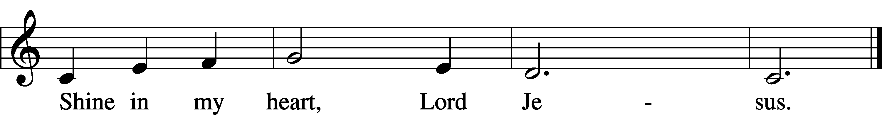
Text and tune: © 1970, 1975 Celebration. Used by permission: LSB Hymn License no. 110005858
Announcements
Blessing [Numbers 6:24-26]
Pastor: The Lord bless you and keep you.
The Lord make His face shine on you and be gracious to you.
The Lord look upon you with favor and give you peace.
People: Amen.
Sending Song Brightest and Best of the Stars of the Morning LSB 400 1, 4, 5
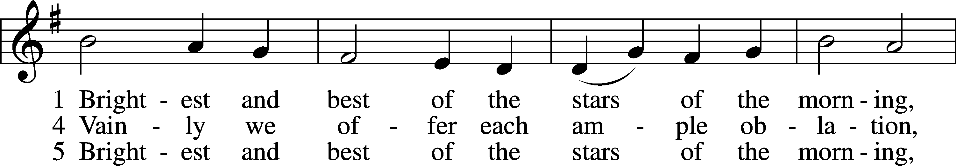
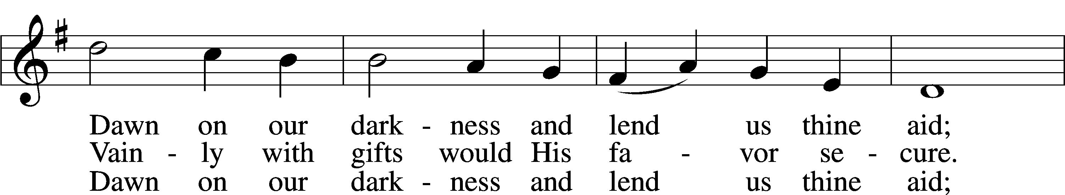
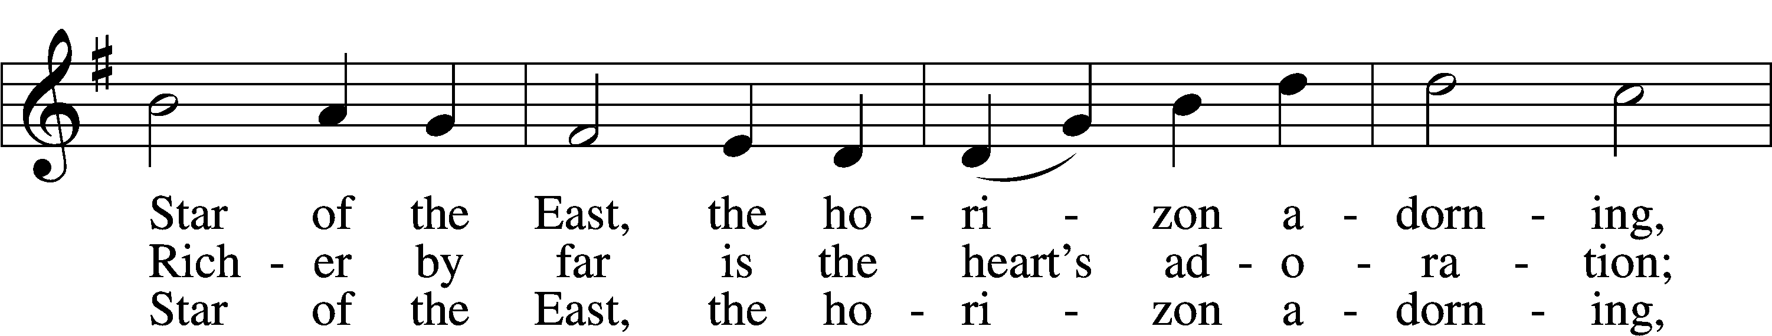
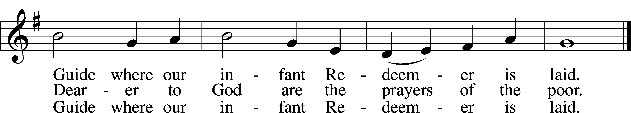
Text and tune: Public domain

Creative Worship for the Lutheran Parish, Series C, Quarter 1. Copyright © 2021 Concordia Publishing House. All rights reserved. Used by permission.

Acknowledgments
Unless otherwise indicated, Scripture quotations are from the ESV® Bible (The Holy Bible, English Standard Version®), copyright © 2001 by Crossway, a publishing ministry of Good News Publishers. Used by permission. All rights reserved. Created by Lutheran Service Builder © 2021 Concordia Publishing House.

